Report On
MEAN Stack Essentials:
A Hands-On 5 Day Bootcamp

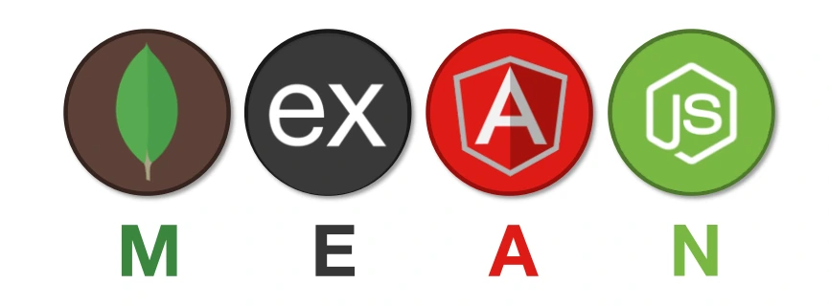
Name: VASANTHKUMAR S
Register No: 6176AC23UIT059
Department: B. Tech – Information Technology
Year: III Year / VI Semester
GitHub Profile:
https://github.com/svk-vasanthkumar
LinkedIn Profile:
https://www.linkedin.com/in/svk-vasanthkumar/

Day 1 – Introduction to MEAN Stack and Form Validation
Date: 02-02-2026
Theory Session:
On the first day, a theory session was conducted to explain the basics of the MEAN Stack. it is used to develop web applications using JavaScript.
The trainer explained the meaning of MEAN Stack:
- MongoDB – Used to store data
- Express.js – Used to create server-side applications
- Angular – Used to design the frontend
- Node.js – Used to run JavaScript on the server
An overview of how these technologies work together was explained in a simple manner. This session helped to understand the basic structure of full-stack web development.

Practical Session:
In the practical session, a simple form validation project was created using HTML, CSS, and JavaScript.
A single-page HTML file was used.
A form was created using the <form> tag. The form included basic fields such as Name, Email, and Phone Number. JavaScript was used to validate the input data.
After entering the details and clicking the Submit button, the entered data was displayed on the next page section. A Clear Data button was also provided to remove the displayed details and reset the form.
This practical session helped to understand how form validation works and how user data can be displayed dynamically using JavaScript.

Outcome of Day 1:
- Learned the basic concept of MEAN Stack
- Understood form creation using HTML
- Learned simple validation using JavaScript
- Displayed and cleared user data dynamically

Hands-on Project - Day 1:
This hands-on project was created using HTML, CSS, and JavaScript.
A simple form was designed to collect user details like name, email.
JavaScript was used to validate the form inputs before submission.
After clicking the submit button, the entered data was displayed on the next page section.
The page did not reload because it was a single-page application.
A clear button was provided to remove the displayed data.
This project helped me understand basic form validation and user input handling.
Program:
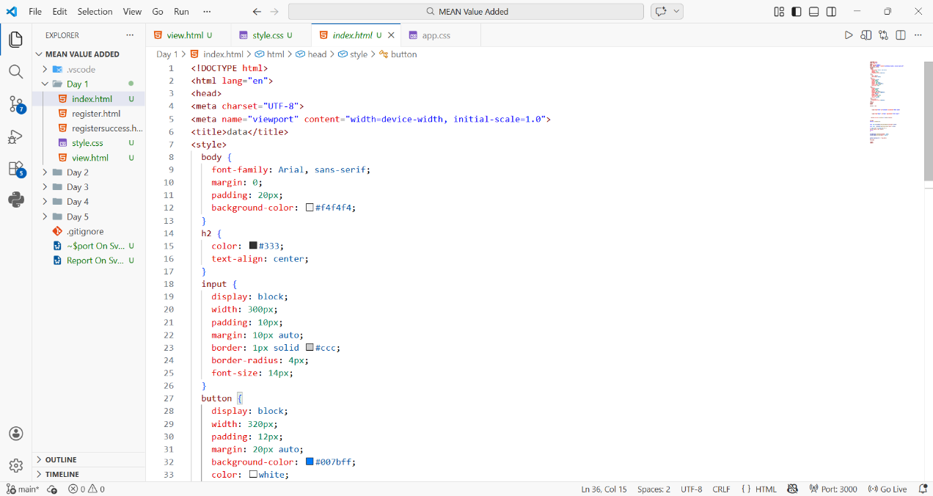

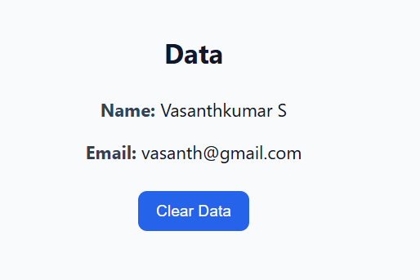
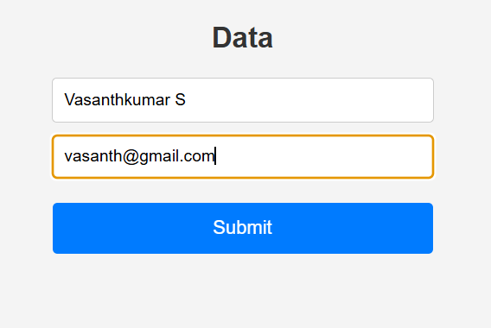
Output:

Day 2 – Hands-On Projects Using JavaScript
Date: 03-02-2026
Practical Session:
On Day 2, a hands-on practical session was conducted using HTML, CSS, and JavaScript. Multiple small projects were developed to understand JavaScript logic and user interaction.
Projects Done on Day 2:
- Calculator Application
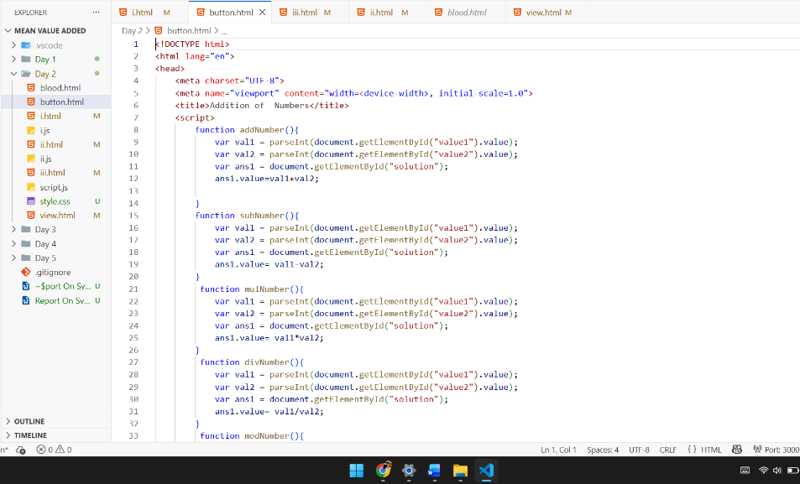
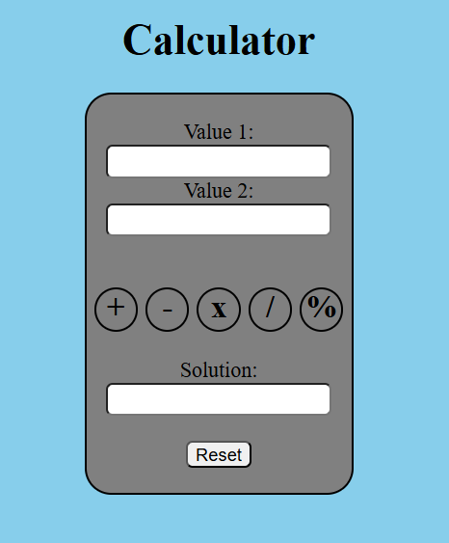
A simple calculator was created using HTML and JavaScript. It was used to perform basic operations such as addition, subtraction, multiplication, and division. This project helped to understand button cl ick events and JavaScript functions.

- OTP Generator
An OTP (One Time Password) generator was developed using JavaScript.
When the button was clicked, a random OTP number was generated and displayed on the screen. This helped to learn random number generation using JavaScript.
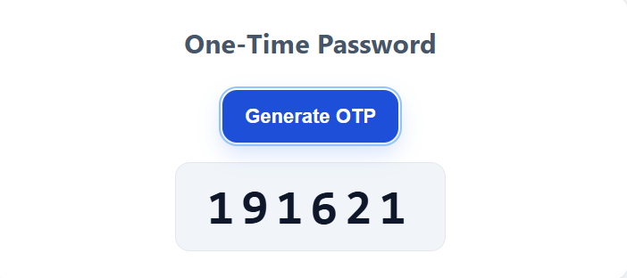

3. Username and Password Validation
A login page was created where the user enters username and password.
- If the entered details were correct, a welcome message with the user name was displayed.
- If the password was wrong, a “Wrong Password” message was shown.
This activity helped to understand conditional statements in JavaScript.
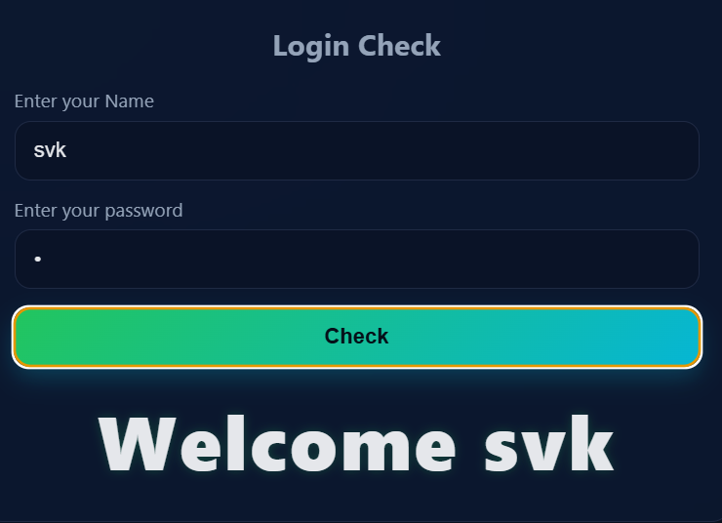

4. User Details Storage Using Local Storage
In this project, user details were entered in a form and displayed on the next page section.
The entered data was stored using browser local storage.
Even after refreshing the page, the stored data remained available.
This helped to understand how data can be stored and retrieved using JavaScript.

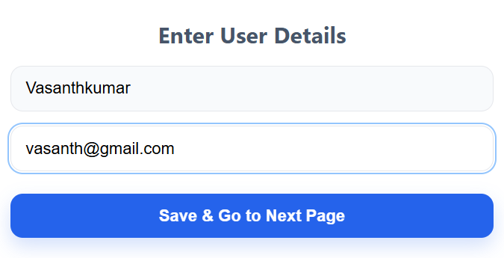

Day 3 – Node.js and Express Concepts
Date: 04-02-2026
Theory and Practical Session:
On Day 3, important Node.js and Express.js concepts were explained with simple examples. Both theory and hands-on practice were done to understand how backend works.
Concepts Learned on Day 3:
1. Event Emitters
Event Emitters were introduced using Node.js events API.
We learned how to create an Event Emitter, listen to events using on(), and trigger events using emit(). This concept helps to understand how events work in Node.js.
2. HTTP Server
A basic HTTP server was created using http.createServer().
The server listens on a port and sends a response to the browser.
This helped to understand how a server works in Node.js.
3. File System Module
The File System (fs) module was used to read and write files.
We learned how to create and delete files using both synchronous and asynchronous methods.
Streams were also explained for handling large files.
4. OS Module
The OS module was used to get system information.
Details such as platform, memory, and CPU information were accessed using this module.
5. Path Module
The Path module was used to work with file paths safely.
Functions like join, resolve, basename, and extname were explained.
This helps to manage file paths correctly.
6. Express Basics
An introduction to Express.js was given.
We learned how to create an Express application, define routes, and send responses to the browser. Middleware concept was also briefly explained.

7. Express with Static Files
Express was used to serve static HTML files.
Simple routes were created and linked with HTML pages.
This helped to understand how frontend and backend connect.
Learning Outcome of Day 3
- Understood core Node.js modules
- Learned how to create a basic server
- Gained knowledge of Express.js routing
- Understood real project file structure
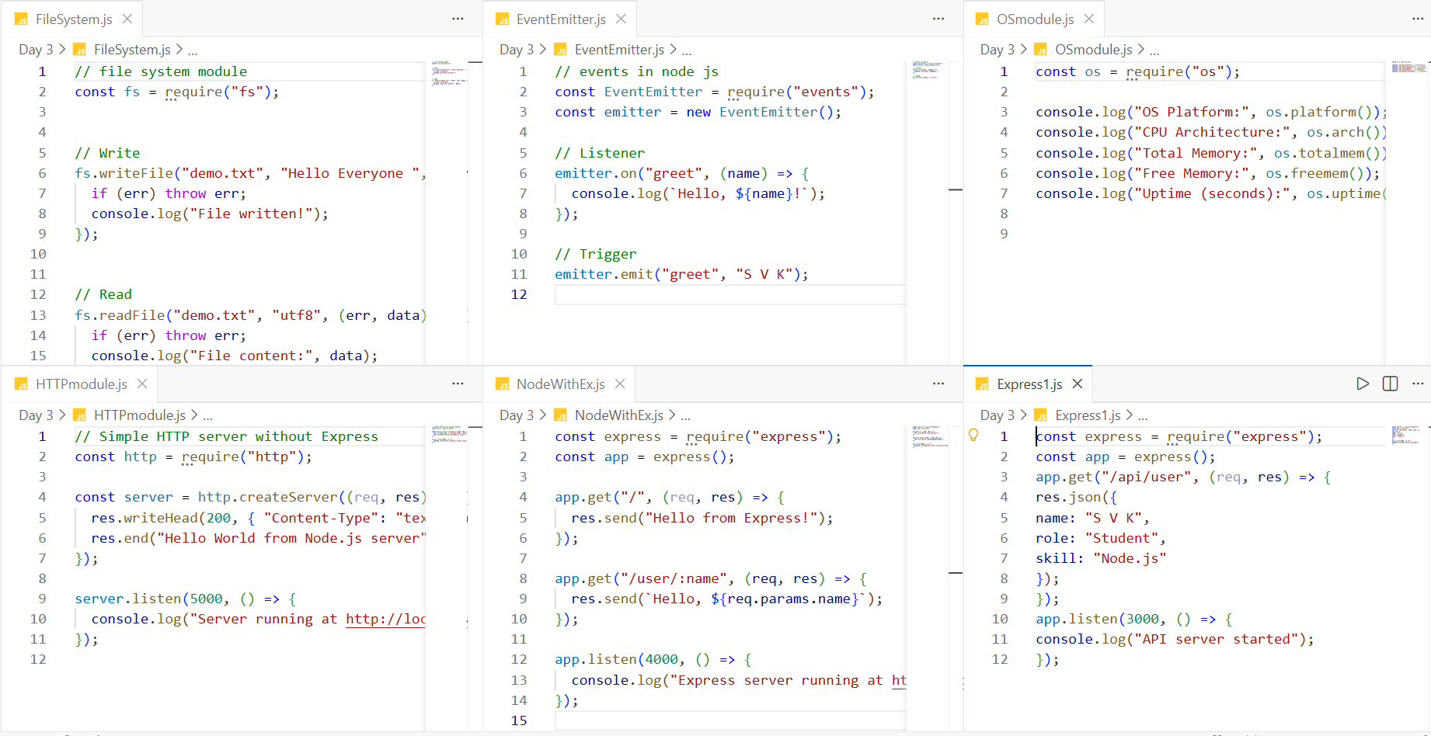

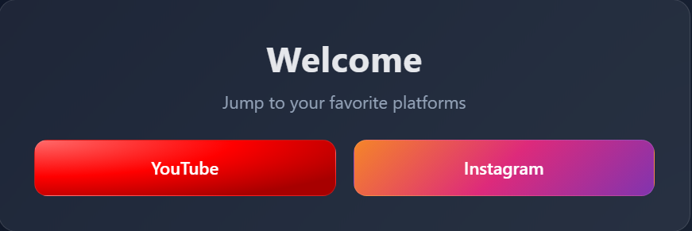

Day 4 – MongoDB Basics and Project Implementation
Day: 05-02-2026
Theory Session:
On Day 4, we learned the basics of MongoDB. MongoDB is a NoSQL database used to store data in document format.
The trainer explained basic MongoDB concepts such as:
- Database
- Collection
- Document
Basic MongoDB commands were taught to:
- Create a database
- Create a collection
- Insert data
- View data
- Update data
- Delete data
A simple database was created using MongoDB commands, and employee details were stored for practice.
Practical Session:
In the practical session, MongoDB was connected with Node.js and Express.js.
First, a simple program was written to connect Node.js with MongoDB.
Data was inserted and retrieved from the database successfully.
After that, Express with MongoDB was explained.
An Express application was created to handle form data and store it in MongoDB.
Project Implementation – Bus Booking Application
A Bus Booking project was implemented using Node.js, Express.js, and MongoDB.
- On Day 3, the bus booking project stored passenger details using local storage.
- On Day 4, the same project was improved by connecting it with MongoDB.
Passenger details such as Name, Age, Source, Destination, and Seat Number were entered through a form.
After submitting the form, the data was stored permanently in the MongoDB database.
This helped to understand the difference between local storage and database storage.
Learning Outcome of Day 4
- Understood MongoDB basics and commands
- Learned to connect MongoDB with Node.js
- Used Express.js with MongoDB
- Implemented database storage in a real project
- Understood CRUD operations
Output:
